Philosophy tetrahedron type model

This document describes the philosophy of the tetrahedron type model. Shell and TNO should agree on these outlines, before the functional design is made. This document deals only with the concepts; the functional design will describe the functionality of the tetrahedron type model in detail.

The tetrahedron type model is used to import and analyse triangulated surface (GoCad) type models and Eclipse type models in Geomec. The starting point of the analysis of a GoCad type model in Geomec is that the geometry of the GoCad type model is designed using the GoCad program. Geomec imports the geometry of the GoCad type model in the tetrahedron type model and prepares it for geo-mechanical analysis. The GoCad design program is fully responsible for the design of the geometry. This means that all imported surfaces from GoCad are connected to each other and the model is enclosed by surfaces of the boundary. Due to this requirement, the restriction that horizons not cross each other is removed. This allows erosional surfaces and salt layers to be simulated. Geomec offers the functionality to coarsen or refine the surfaces of the model if no borderless surfaces are present (i.e. intrusive bodies). If borderless bodies are present then no surface can be refined. In both cases GeoMec will create a tetrahedron volumetric mesh. If faults are present then, at the users option, the mesh may be discontinuous across the fault. This avoids the need for small tetrahedral to fill in gaps when the offset on the fault is significantly less than the mean length of the triangles making up the surface mesh.

The user can also use an existing volumetric tetrahedron mesh when where the surface model extracted from that mesh is cannot be modified afterwards. This volume mesh can also be discontinuous across fault surfaces. For either the import of a surface mesh or a volume mesh, Geomec will automatically detect bodies in the resulting volume mesh, allow the user to assign these bodies to formations and to assign material properties to those formations. The minimum amount of information required for the volume mesh is the location of bodies. If information about the formations and material properties is present, then that information will be imported but can be overridden by the user. For example, the user can opt to assign constant properties to a layer via Geomec functionality. The imported GoCad type model must be enclosed by a new boundary, consisting of a user-defined rectangle, and a top- and bottom horizon.
The tetrahedron type model exists of two models. The sub model consists of the closed GoCad type model containing properly connected surfaces. The super model contains the boundary, the bottom surface, the overburden and of course the sub model. At the users option, the sub model and the super model may be one and the same. If this is the case, then the user has to supply all internal and boundary surfaces in the submodel and no further surfaces may be added by Geomec.

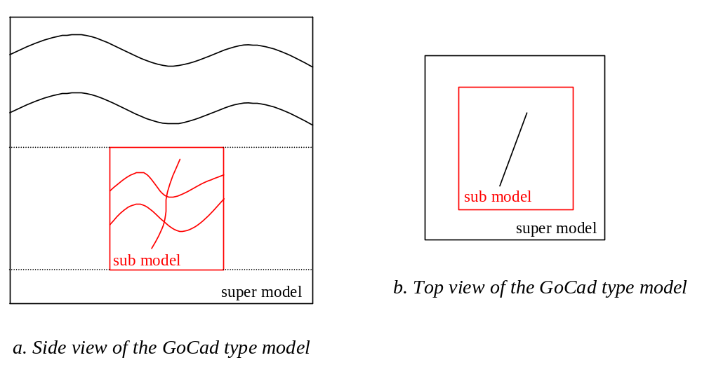

The sub model
The user imports surfaces from the GoCad design program. Some of these surfaces are automatically assigned to the boundary surfaces of the sub model and enclose the sub model. The rest of the surfaces can be assigned to horizons or faults. The user can coarsen or refine the triangular mesh on the surfaces of the sub model. The volumetric mesh of the sub model is generated when all the adjacent surfaces are connected and the boundary surfaces are enclosing the model.

The super model
The super model encloses the sub model and is very similar to the horizon type model. The sub model is enclosed by the boundary, consisting of a user-defined rectangle, and a top- and bottom horizon. The user can add horizons above the sub model and under the sub model under the condition that the surfaces do not cross the boundary of the sub model or each other. Like in the horizon model the horizons can be defined by surfaces or by a constant depth. The surfaces assigned to the horizons of the sub model and super model are automatically stretched to the boundary of the super model. The super model cannot contain faults unless the submodel and the super model coincide. Then any faults that extend to the edge of the submodel will extend to the edge of the super model. The surfaces of the super model can be coarsened or refined. Finally a volumetric mesh can be generated for the entire model.

Assigning loads and materials
The refinement of the volumetric mesh depends on the refinement of the surfaces. The generation of the volumetric mesh results in a number of bodies. A body is defined by tetrahedrons enclosed by the surfaces of the horizons, faults and boundary of sub- and super model and will be assigned to a formation with the name of the upper horizon of the body. Each body can be assigned to a formation. A formation can contain multiple bodies. The user can assign pressures and material properties to a formation. When pressures and materials have been assigned for all formations, the user can start the analysis. The post processing of the tetrahedron type model works in a similar way as in the horizon model.

